10.74: Break into 2 parts, the rough and smooth sections.
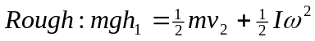
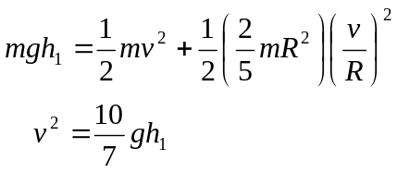
Smooth: Rotational KE does not change.

